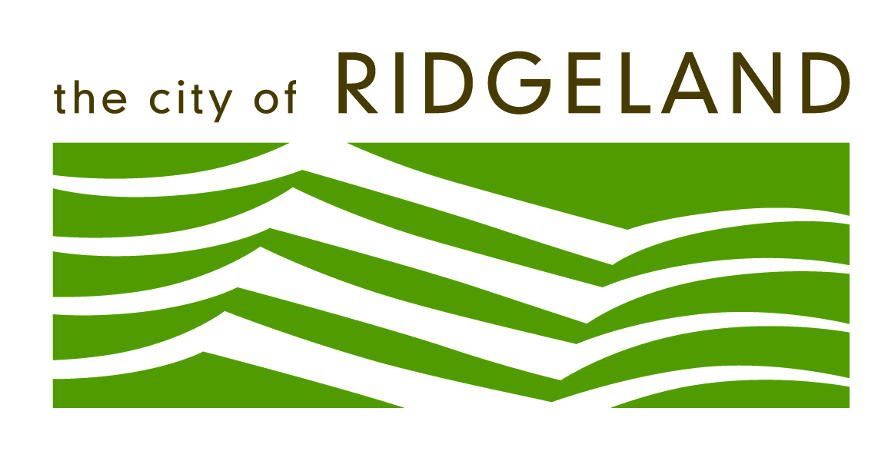

Public Works Department

2016 Annual Review

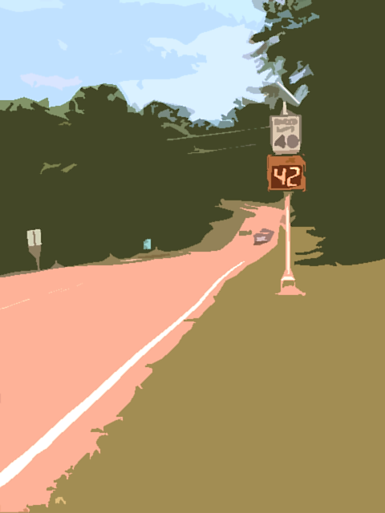

Table of Contents
Introduction and Overview 3
Mission Statement 2
Goals and Objectives 4
Projects and Programs 6
Active Projects List 17
Significant Accomplishments 18
Executive Summary 19

Introduction and Overview

This report will include the status and environmental stewardship effort of all active and completed projects during this rating period.

Mission Statement

Each day The City of Ridgeland Public Works Department will provide and maintain potable drinking water, sanitary sewer, storm sewer, streets, solid waste, mosquito control, and cemetery services as required in an effective, environmentally conscious and safe manner to ensure the health, safety, welfare and a high quality of life for all Citizens.

Directors Intent:

We work for the citizens of Ridgeland and will treat them with dignity and respect. We will use new technology to increase our productivity and efficiency. Our projects will include environmental stewardship, livability and quality of life integrated into their development. The Public Works Department will participate with other City Departments to accomplish the mission of the City. We will plan, prepare and execute our emergency response plans in conjunction with other agencies and City Departments. We will accept risk in mission accomplishment to accommodate the safety of our employees. We will recruit the most professional and qualified employees possible commensurate with the job position.

The Public Works Department is a dynamic organization that is comprised of 61 personnel and has an annual operating budget of $8.4 million dollars. We maintain 360 miles of water and sanitary sewer infrastructure and easements, 115 miles of streets and street right-of-way, 120 miles of storm drains and ditches, 35 traffic signals, 1000 + street lights, five water tanks, eight water wells, 8,400 water meters read every month, maintain over 100 City vehicles (from other departments) and operate Jessamine cemetery. We manage the East Madison County Regional Sewer and Ridgeland West Sewer systems for Ridgeland, the City of Madison and Pearl River Valley Water Supply District. The department also manages the solid waste, recycling, and landscaping, and cell phone tower contracts with a total annual dollar amount over $2 million dollars. These are only the specified tasks and do not include all of the implied tasks required to make all of this happen.

I am pleased to report that the City of Ridgeland Public Works Department is on track to accomplish all of its goals and objectives.

Major projects completed during this rating period include:

- FEMA Debris Removal and Monitoring Term Bid Contracts
- East Madison County Regional Sewer Lining
- Old Canton Road Crosswalks
- Lake Harbour Extension Right of Way
- Colony Park Blvd Right of Way
- South Wheatley Street Rehabilitation
- Induction Lighting at Traffic Signals
- Highland Drive Sanitary sewer
- Local Street Repair and Overlay on 29 different streets

Miscellaneous Improvements

- Speed Limit Driver Feedback Signs
- Traffic Radar Speed Counters
- Northpark Drive traffic calming signage and pavement markings
- County Line Road/Hwy51 “no truck signs”
- Old Agency Village sidewalk trip hazard removal
- Emergency Battery Backup System for Hwy 51/Rice Road traffic signal
- Traffic signal meter base completion
- I-55 Split Diamond traffic signal completion
- EMCRS- Metering Station Tech and assistant added to maintain these stations.

Our active projects for the upcoming year include:

Introduction and Overview

This report will include the status and environmental stewardship effort of all active and completed projects during this rating period.

Mission Statement

Each day The City of Ridgeland Public Works Department will provide and maintain potable drinking water, sanitary sewer, storm sewer, streets, solid waste, mosquito control, and cemetery services as required in an effective, environmentally conscious and safe manner to ensure the health, safety, welfare and a high quality of life for all Citizens.

Directors Intent:

We work for the citizens of Ridgeland and will treat them with dignity and respect. We will use new technology to increase our productivity and efficiency. Our projects will include environmental stewardship, livability and quality of life integrated into their development. The Public Works Department will participate with other City Departments to accomplish the mission of the City. We will plan, prepare and execute our emergency response plans in conjunction with other agencies and City Departments. We will accept risk in mission accomplishment to accommodate the safety of our employees. We will recruit the most professional and qualified employees possible commensurate with the job position.

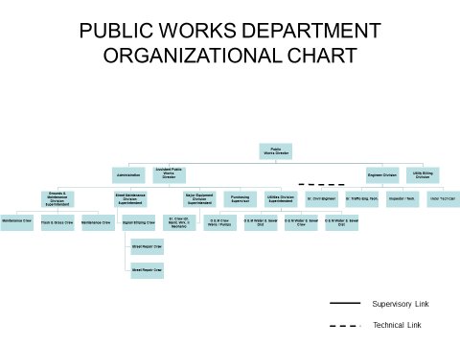

Goals and Objectives

The following are the goals and objectives that the Mayor agreed to at my last evaluation. These goals and objectives are supported from the director down to the crew leader level. A semi-annual review of these goals are discussed or amended as agreed to between the rated individual and the rater.

- Goal – To increase the efficiency of work in the Public Works Department in order to provide timely and quality service to the Citizens of Ridgeland.
  - Objectives
    - Update/Improve on essential task and supporting task for each division in order to provide guidance on what is to be accomplished through developmental counseling.
    - Conduct a field evaluation and After-Action- Review annually on how essential tasks are accomplished in order to determine what tasks need to be sustained and need improvement
    - Ensure that all supervisory personnel successfully complete management training provided by the Mississippi Personnel Board
    - Brief the Mayor and Board on requirements and recommendations that resulted from the assessment
    - Update and add units to the vehicle tracking system

- Goal - To conduct an analysis on all contract services to determine the most cost effective methods and to achieve the highest level of service in the least amount of time
  - Objectives
    - Provide recommendations to the Mayor and Board of Aldermen on the following services: Trash disposal, recycling, mosquito control, street cleaning, meter reading and landscaping
    - Continue a yard debris pick up service on a monthly basis utilizing the knuckle boom truck.
    - Recommend to the Mayor and Board the most cost effective and highest quality recycling and solid waste services.
    - Increase our participation and education of recycling services by including multi-family and small business in the program.

- Goal - To improve the personnel evaluation system in order to provide incentives to employees who excel
  - Objectives
    - Agree on goals and objectives for each employee that I rate in order to translate the Mayor and Board of Alderman’s vision on what is to be accomplished
    - Ensure that goals and objectives are established by my subordinates and the people that they rate.
    - Review goals and objectives with my subordinates every six months and ensure they do the same with their subordinates in order to track progress and make necessary changes

Goals and Objectives

- Goal - Establish a method to complete work orders over 30 days old (Ongoing)
  - Objectives
    - Conduct a weekly staff meeting to determine why work orders are not being completed and hold the Assistant Public Works Director accountable to complete over-due work orders

- Goal - Provide employees an opportunity for a higher level of training to foster upward mobility.
  - Objectives
    - Conduct backhoe, tractor, chipper, and chainsaw operations classes and hands on training at least two hours per week
    - Offer at least eight hours of institutional continuing education to each employee that is job related
    - Superintendents will successfully complete the Basic Supervisory Course sponsored by the Mississippi Personnel Board
    - Require a Class A CDL license for all truck drivers where required

- Goal - Establish a plan to help mitigate the effects of natural and manmade disasters
  - Objectives
    - Exercise the emergency plan on how to plan, prepare and execute procedures to reduce the loss of life and property
    - Attend the Hurricane Conference and associated training
    - Establish and maintain an Emergency Operation Center

- Goal - Manage professional services in the planning, preparation and construction of capital projects to ensure professionals are focused on priority tasks
  - Objectives
    - Establish a schedule for capital projects with the who, what, where, when and how as the criteria
    - Conduct a bi-weekly capital projects meeting with the appropriate professionals to ensure deadlines are met on project phases
    - Focus on new road projects such as Lake Harbour Drive Extension and Colony Park Boulevard
    - Review annually the facilities plan for water and sanitary sewer infrastructure

- Goal - Provide better communication with the Mayor and Board of Alderman with regard to project status (ongoing)
  - Objectives
    - Provide an updated briefing format that will provide an overview of project status at a glance
    - Meet with project engineers at least monthly on all active projects to determine the progress on each one.
    - Email a monthly project status report to the Mayor and Board of Alderman
    - Email staff meeting notes to the Mayor and Board Weekly
Goals and Objectives

- Goal - To ensure compliance with all Safe Water Drinking Water Act requirements
  - Objective
    - Maintain chlorine analyzers to ensure four log treatment of the water system
    - Complete the consumer confidence report and correct any deficiencies

Projects and Programs

Environmental:

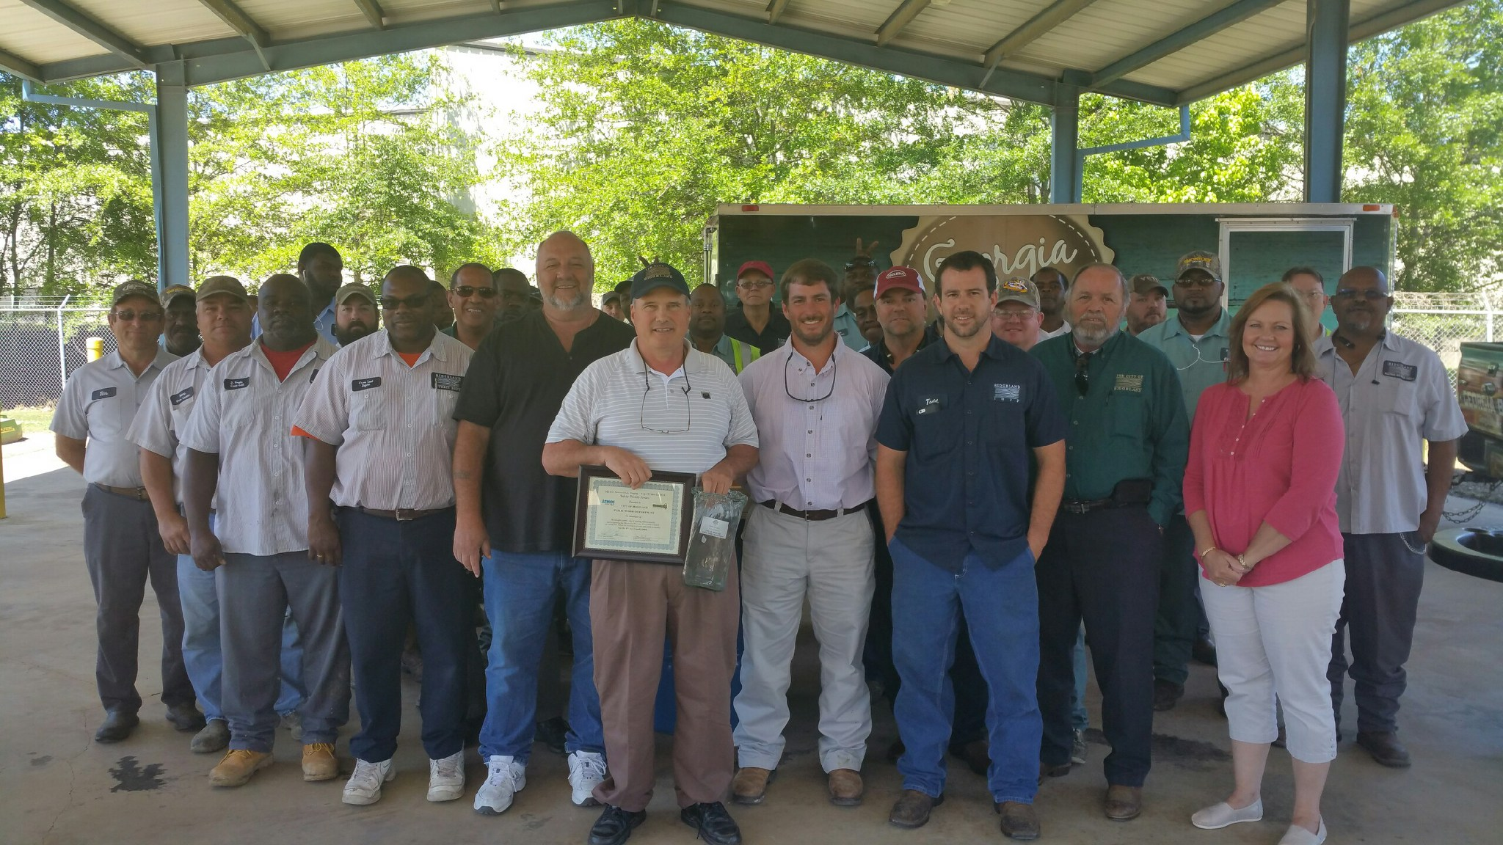
Keep Mississippi Beautiful

The Public Works Department won 1st Place in the category of Local Government. Major Environmental achievements are the support provided to Keep Ridgeland Beautiful, recycling, and conversion to solar power on metering stations.

Atmos 811
The City of Ridgeland Public Works Department was presented with and award as one of the top ten Cities in Mississippi for participating in the “Call before you dig” program.

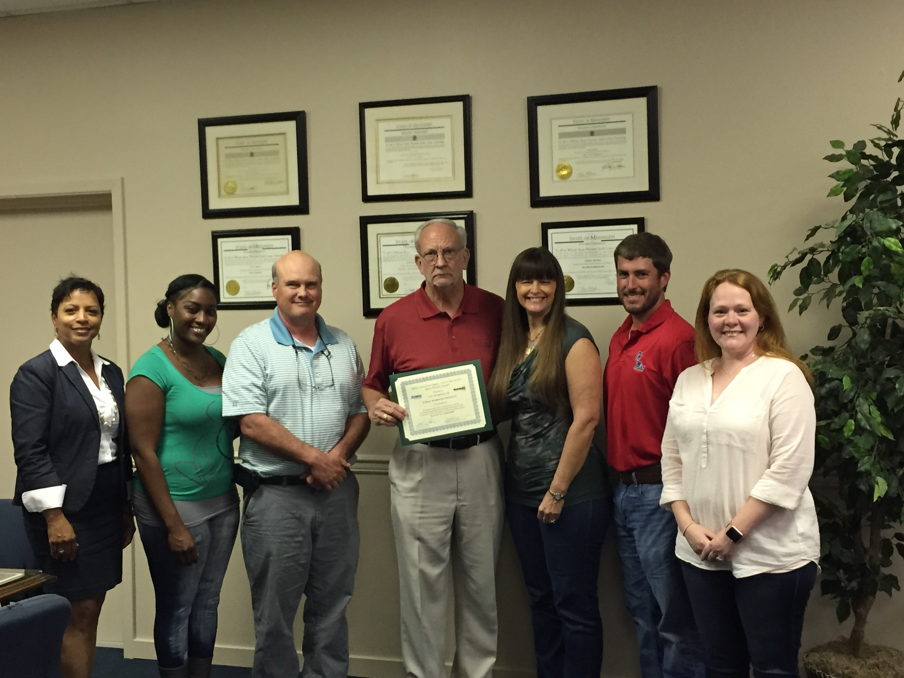
Oil Analysis Program

Oil Analysis Program
Prior to changing the oil in our Public Works Vehicles we sample the oil to determine if a change is needed. The test cost $7.00. We have found that the majority of vehicles do not need the oil changed at the standard 4000 miles extending the time between changes. While all of the data is not in on this program we are optimistic that we can reduce cost and the amount of used oil. We also recycle all of the oil and filters on vehicles we service for the entire City fleet.
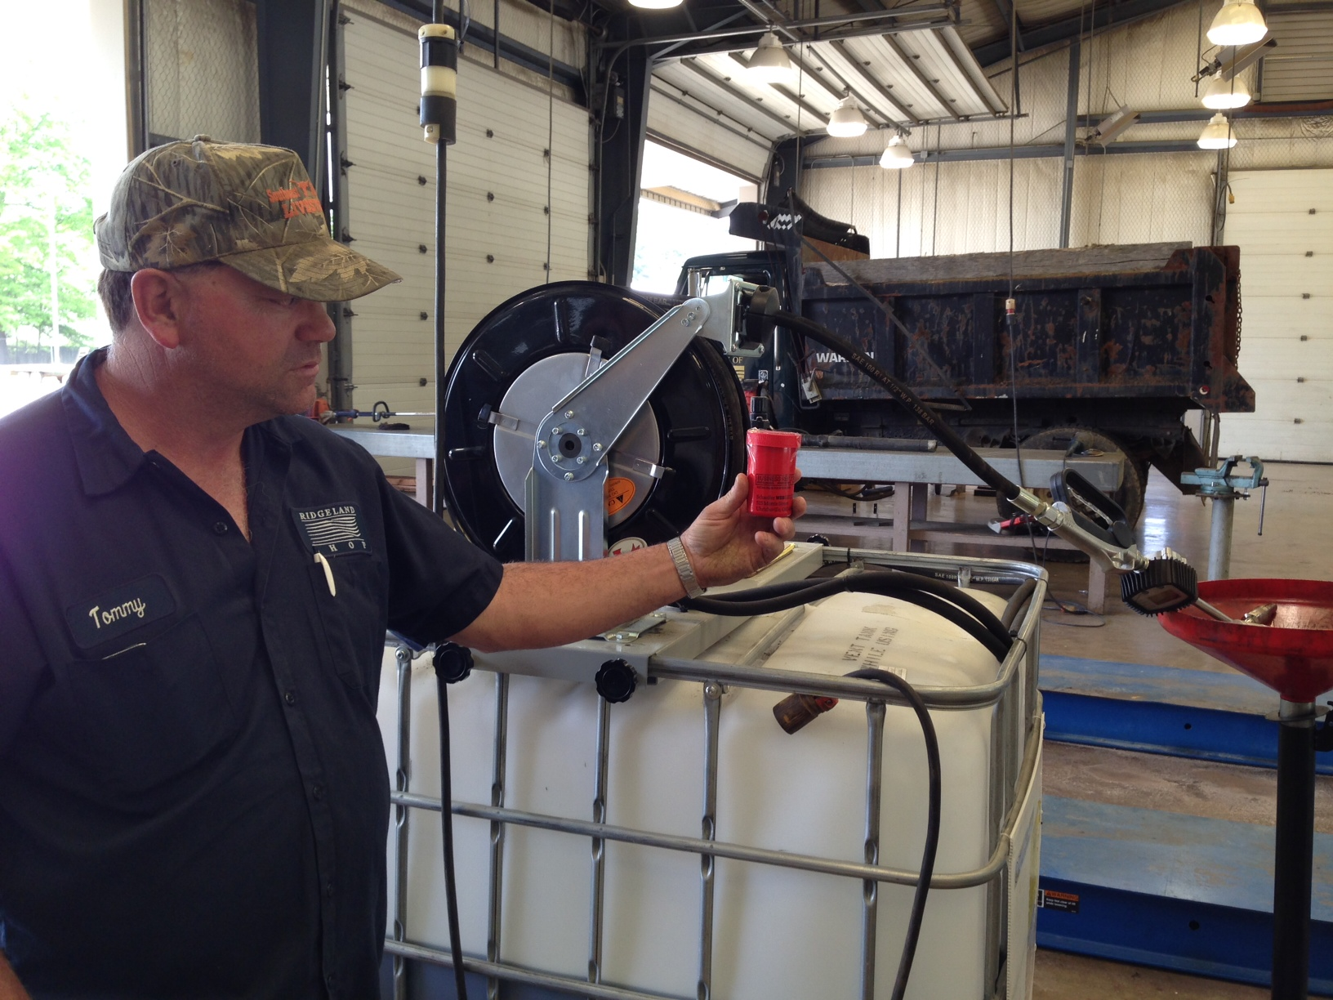

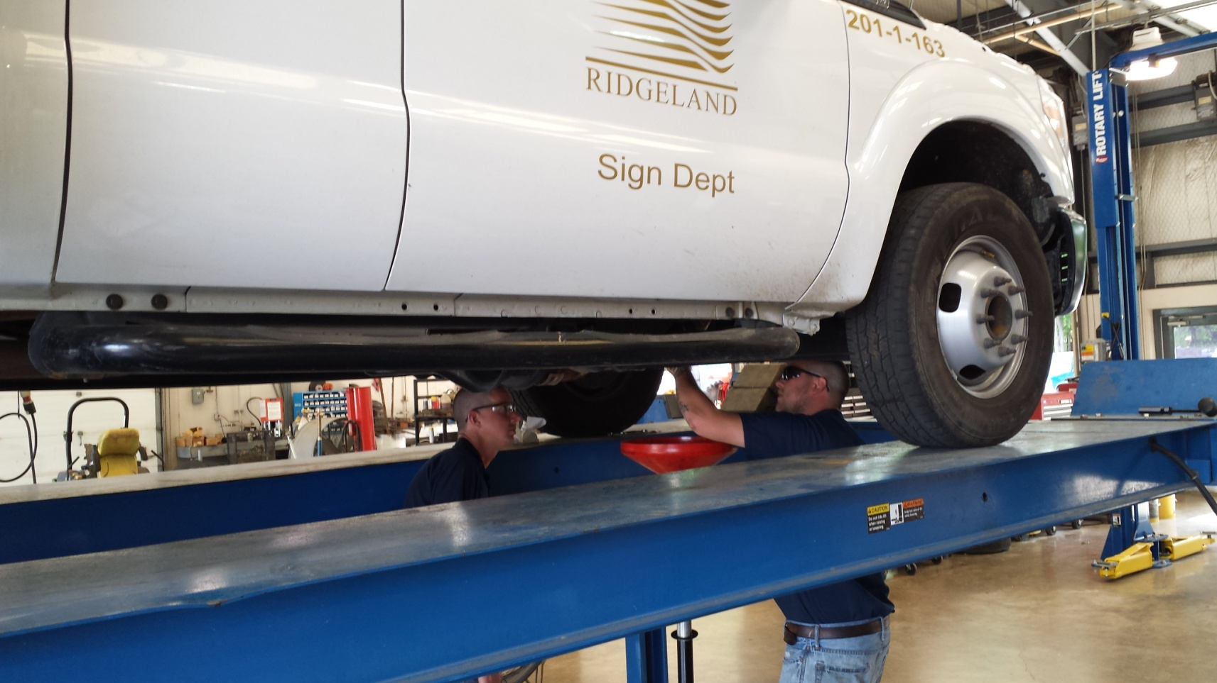

Keep Ridgeland Beautiful

Midway Park
The City of Ridgeland was selected as the “Kick Off City” for the Great American Cleanup for the State of Mississippi in 2015. The Keep Ridgeland Beautiful Committee’s project was to revitalize Midway Park on Midway Avenue. The Committee improved the landscaping, basketball court, added picnic tables, signage, lighting, and flagpole and playground equipment as part of the project. Keep Mississippi Beautiful along with other sponsors provided funding for this project.

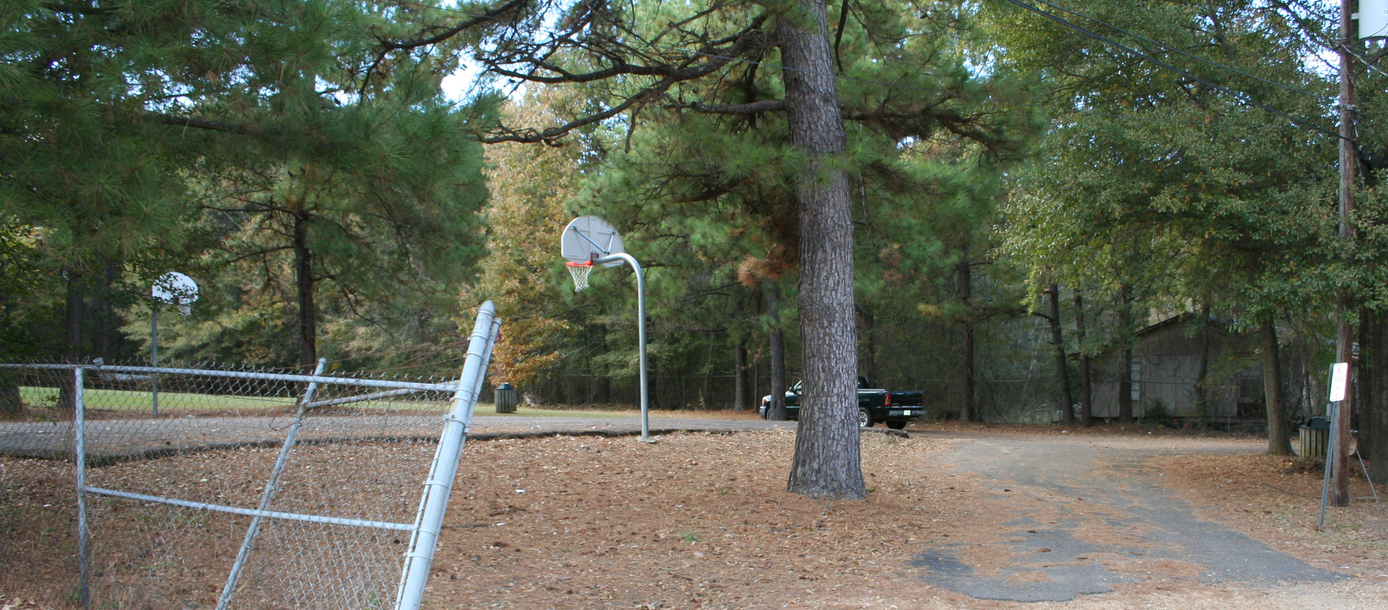

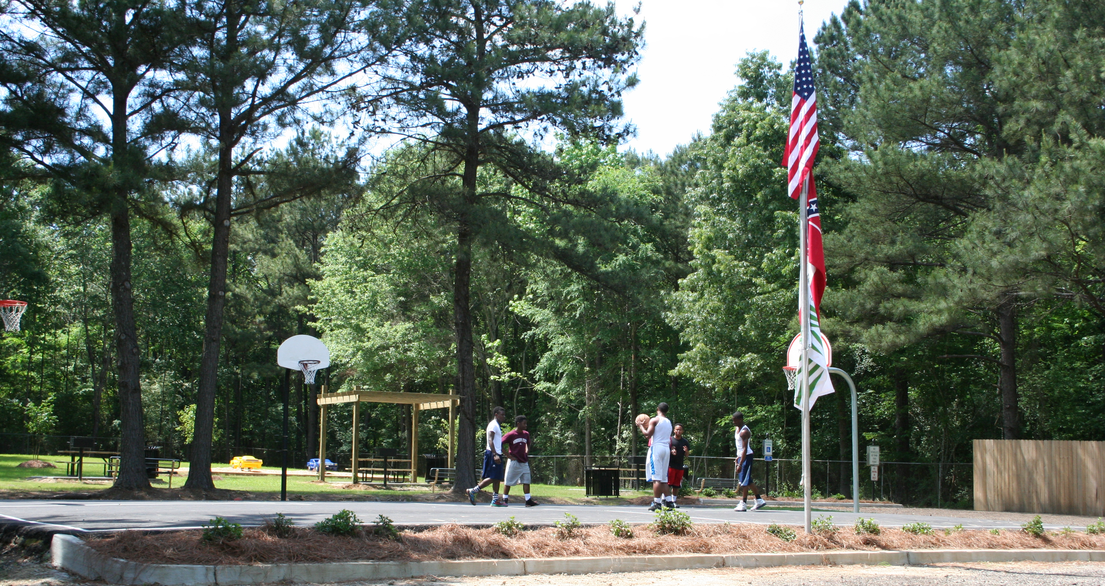
After Great American Cleanup
Before Great American Cleanup

Asphalt Recycling

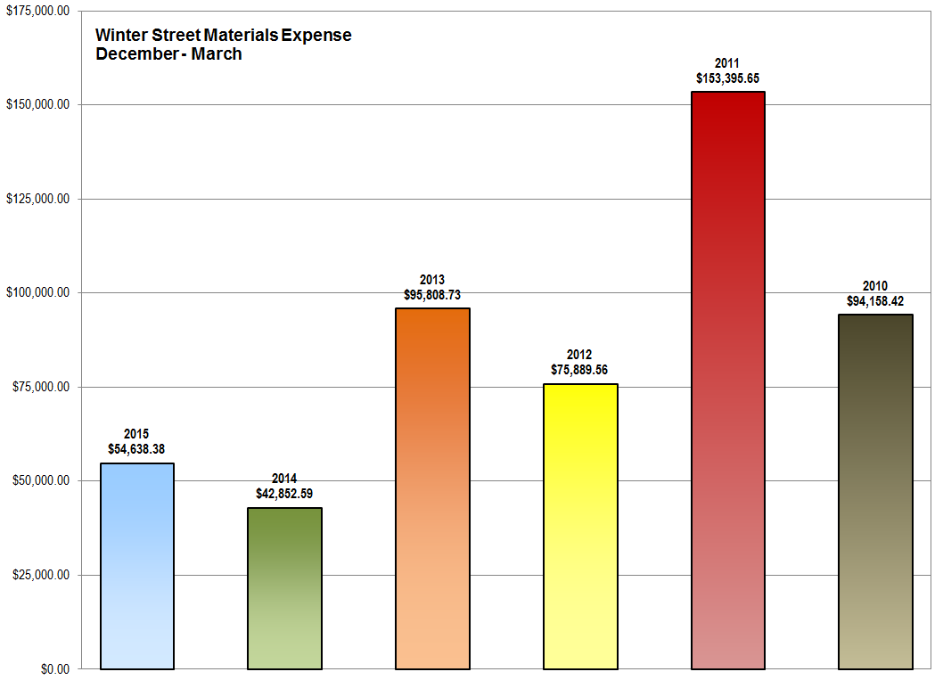
Asphalt Recycing
The City started a new asphalt recycling program this year in order to reduce the cost of street maintenance and the cost of taking milled ashalt to the landfill. We estimate an annual cost savings of over $90,000.00. Our capital investment was just under $100,000.00 for the equipment. We hired a local testing laboratory to test and evaluate our recycled asphalt pavements. Their recommendations were instrumental in optimizing our recycling process and the development of a useful product for our City Streets.

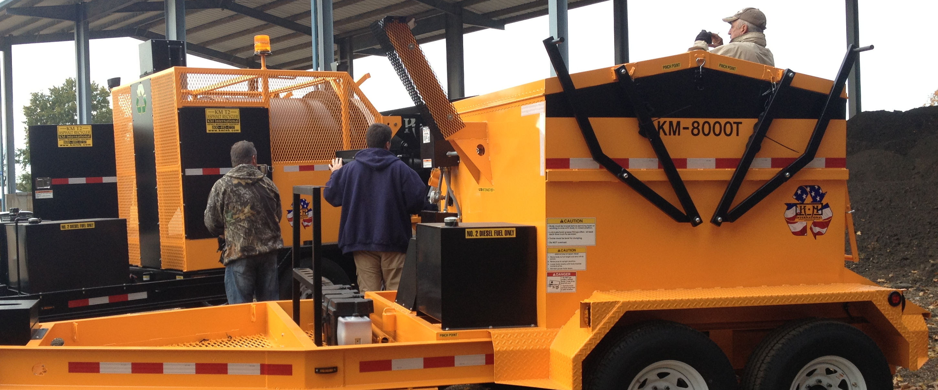

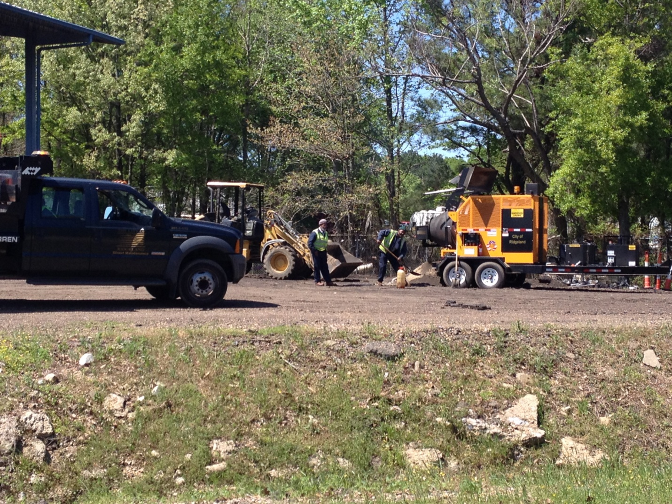

Enhance


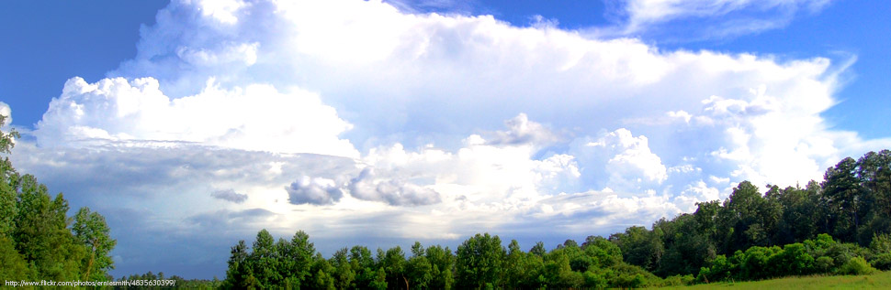

Mississippi Department of Environmental Quality (MDEQ) Enhance Program

Enhance is designed to encourage voluntary environmental stewardship by recognizing committed environmental leaders, thus nurturing the reduction of waste and conservation of resources, resulting in long term economic benefits and continuous environmental enhancement. The Program has three levels of recognition that are Leader, Steward and Associate. The City of Ridgeland is the only City in the State that is currently at the Steward level.

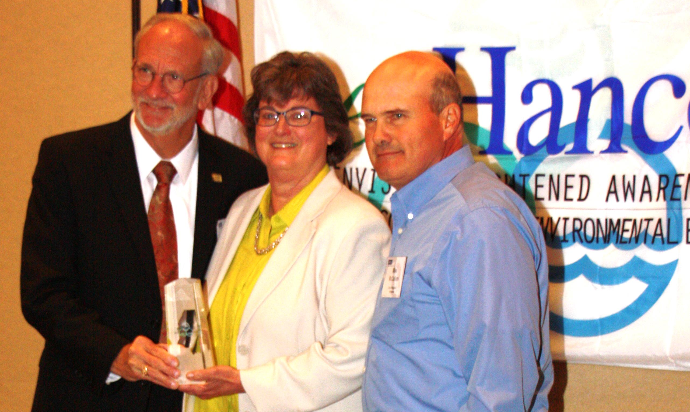
Asphalt Overlay and Pavement Maintenance

Pavement Maintenance
During the reporting period of June 2015 to June 2016, the Public Works Department completed the repair and overlay of 21 different local streets. The primary method of pavement rehabilitation and preservation implemented was mill and overlay the road surface along with base repair of failed areas and repair of failed curb and sidewalk in an effort to maximize budget and extend the life cycle of our roadways.

Streets Completed June 2015 – June 2016

Overlook Pointe Subdivision

Huntington Place Subdivision
Huntington Place
S. Wheatley Street (County Line to School Street)
Longmeadow Subdivision
Longmeadow Drive
Timber Ridge Drive
Timber Lane
Timber Ridge Court West
Timber Ridge Court East
Timber Cove
Meadow Ridge Drive
Longmeadow Cove
Longwood Cove
Bird Lanes
Whippoorwill Lane
Bobwhite Lane
Robinwood Lane
Meadowlark Lane
Bluebird Lane
Mockingbird Lane
Shadowood Subdivision
Pinewood Lane
Holly Lane
Reservoir Area
Yacht Club Road
Copper Ridge Drive

- 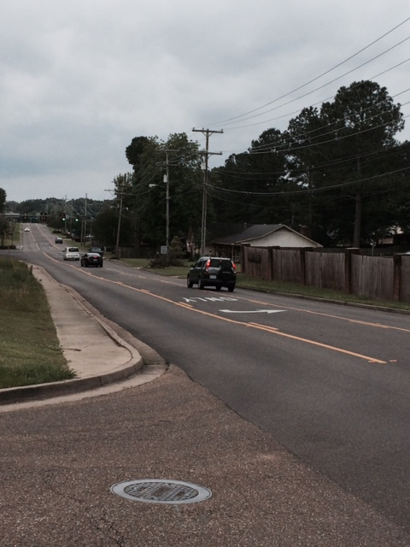
A typical repair of one of our collector streets (South Wheatley) includes: repair of failed curb and sidewalk areas, repair of failed road base areas, milling, resurfacing, and replacement of striping.

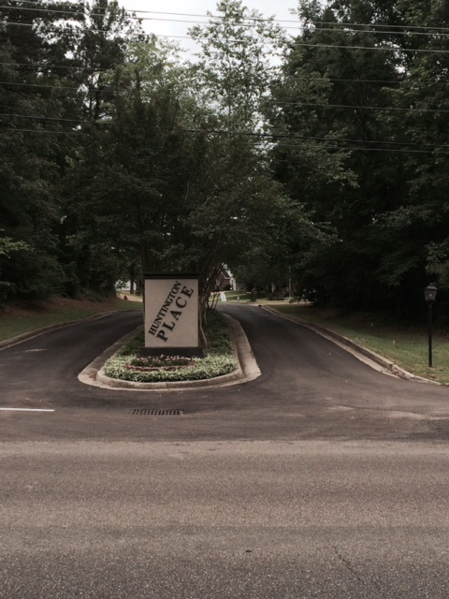
This is a photo of a typical street rehabilitation of a local street at Huntington Place. This process is the repair of failed areas, curb repair, milling and asphalt overlay. Our goal is to rehab 10% of our streets annually.

Drainage Projects

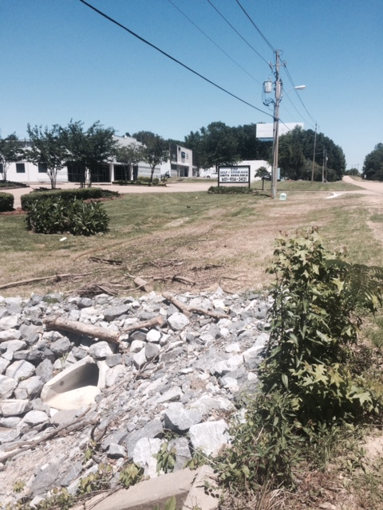
Replacement of a failed concrete drainage pipe in and severely eroded ditch on Cole Road. A new pipe was installed along with regarding and sodding.

Sanitary Sewer Rehabilitation

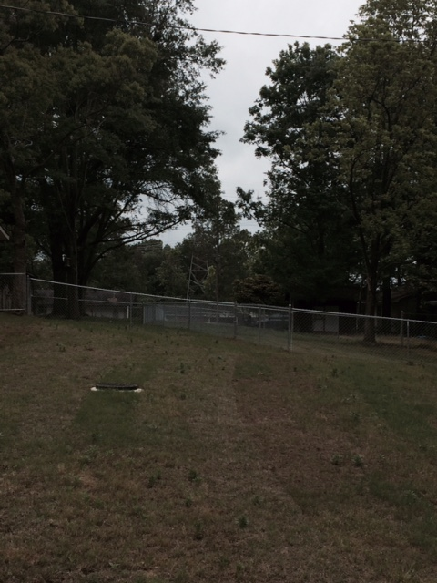
Highland Drive Sanitary Sewer Replacement. Pictured is a manicured sanitary sewer easement where the City replaced a failing collection system.

Active Projects List

  - Lake Harbour Drive Extension, Hwy 51 to Highland Colony Parkway:
Final Design is 90% complete. Right-of-way acquisition phase of the project is complete. We are now waiting on utility relocation.
  - Samuels Lane Water Well: Under Construction- 70% complete buildings under construction

  - Craft Center Parking Lot Improvements:

    - Project “B” –Notice to proceed was issued May 4th
    - Project “C” – Notice to proceed was issued May 4th

  - Colony Park Boulevard Right-of-way acquisition phase of the project is complete. We are now waiting on utility relocation.

  - East Jackson Street Multi-Use Trail: Design complete however due to the high cost of utility relocation we are considering moving the trail to the south side of Jackson Street.

  - Highland Colony Parkway South Rehabilitation- We estimate a July bid date for the county portion and City Portion

  - Highland Drive Sanitary Sewer Replacement. Complete.
  - Highway 51 Sanitary Sewer Line from Prassel Lumber Company to Purple Creek:
Construction is anticipated FY2017. The City is saving an estimated $10,000 in consultant fees by designing the project using Public Works staff.

  - Old Agency ditch stabilization- Start Date is June 1st 2016
  - Old Canton Road Sidewalk Improvements, Complete
  - South Wheatley Street Rehabilitation, Complete
  - Induction Street Lighting at Traffic Signals

  - FEMA Debris Removal and Monitoring Term Bid Contract Establishment

Significant Accomplishments

- Served on the Intermodal Transportation Technical Committee and helped to facilitate the approval of funds for MAP 21 projects
- Served on the Intermodal Transportation Sub-Committee and was instrumental in developing the change to prospectus regarding late projects and reallocation of funds
- Served on the Madison County Wastewater Authority Technical Committee
- Served as Staff Support of the Keep Ridgeland Beautiful Committee
- Served on the Mississippi Recycling Coalition Board of Directors
- Won the award from Keep Mississippi Beautiful for local government
- Served as the Safety Officer and chairman of the Executive Safety Committee
- Served on the Madison County Transportation Committee

- Assisted Madison County in the execution of House Hold Hazardous Waste Day

- Applied for and received 3.3 million for Lake Harbour Extension $215,000.00 for Highland Colony Parkway Rehab and $350,000.00 for East Jackson Street Multi-Use Trail from the MPO.

- Attended the American Public Works Association Annual Conference
- Conducted an informational brief to the Mayor and Board on infrastructure requirements
- Regularly provided the Mayor, Board members and other Department Heads minutes of the weekly staff meeting and monthly project status report meeting.

- Maintained Water and Wastewater Operator Certification from the Mississippi State Department of Health and Environmental Quality
- Completed over 4,874 requests for services, an increase of 3100 over the previous year in addition to everyday tasks
- Managed all professional service contracts to include landscaping, solid waste, recycling, water tank maintenance, cell tower and engineering
- Updated the annual request for proposals package and contract documents for FEMA eligible disaster debris removal, monitoring and management services in accordance with the latest FEMA regulations to ensure the City has the necessary services in position to recover from a disaster event and receive Federal and State assistance.
- Continued the Oil Analysis Program to reduce the number of vehicle oil changes required
- Maintained records on over 60 vehicles on the tracking system that have kept vehicle accidents to a minimum
- Managed cell phone leases to ensure payments are now coming to the City of Ridgeland in the amount of $301,000.00 annually.
- Prepared five budgets for Utilities, Street, East Madison County Sewer, Health and Welfare and Jessamine Cemetery
- Managed the Recycle Bank Program
- Sustained a four-day workweek in order to improve efficiency and reduce operating expenses.

- Facilitated the recertification of the City in the Enhance Program by expanding the recycling program to include solar powered recycling compactors and asphalt recycling.

- Received a perfect 5.0 score from the Mississippi Department of Health for Water System Operation and Management making it one of best-managed water systems in the state.
- Named a Bicycle Friendly Community by the League of American Bicyclists

- Completed a program to calibrate and rebuild water well flow meters to increase the accuracy of water loss reporting.

- We maintained a class 6 flood insurance rating that gives all flood insurance policy holders in the City of Ridgeland a 20% discount on their renewals.

Executive Summary

The City of Ridgeland Public Works Department is once again taking a proactive approach in the execution of the Ridgeland Area Master Plan, Transportation, Water and Sewer Capital Improvements Plans, the City Mission and Environmental Policies. One area of concern is the long range funding for the maintenance of our Arterial and Collector Streets and water and sanitary sewer infrastructure.
Arterial and Collector Street Long Term Maintenance



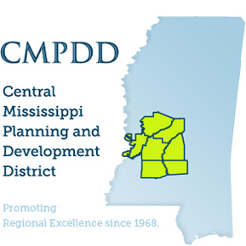

Outside Funding Obligated for Public Works Department Projects
June 2014 – June 2015

FUNDING OBLIGATED
$11.5M in Federal Funding committed for Lake Harbour Drive Extension Construction
$3.3M in STP Funding committed for Lake Harbour Drive Extension Construction
$1.0M in Madison County Funding for Lake Harbour Drive Extension Construction
$1.0M in State Legislature Funding for Lake Harbour Drive Extension Construction
$375,000 in STP Funding for Craft Center Parking Lot Overlay Construction Reimbursements
$375,000 in STP Funding for Craft Center Parking Lot Overlay Construction Reimbursements
$800,000 County Road and Bridge Tax
$215,000 in STP Funding committed for Highland Colony Parkway Construction
$194,000 in EPA Funding for Samuels Lane Water Well Construction
$1.5 M in Stat Legislature funding for Lake Harbour Drive Extension Construction
$1,023,377 in DWSIRLF Funding for Samuels Lane Water Well Construction
PUBLIC WORKS PROJECT SERVICES
The following is a list of the estimated savings in consultant fees as a result of using Public Works staff to design and administrate construction projects.
$110,000 in Samuels Lane Water Supply Well Design, Permitting, and Contract Administration
$30,000 in East Jackson Street Multi-Use Trail Design and LPA Project Administration
$10,000 in Highland Drive Sanitary Sewer Replacement Design

Major Infrastructure Concerns:

Arterial and Collector Streets-The City has made significant strides toward the rehabilitation of local (neighborhood) streets increasing its budget to include a minimum of 10 % of those streets each year. This commitment by the City will ensure that those streets are maintained to an adequate standard regarding service levels. The rehab of our arterial and collector streets are an area of concern because these are large expensive projects that require bond issues or other borrowed money to pay for. We have received a certain amount of these funds to come from the County and to a lesser degree from the Metropolitan Planning Organization. The City currently has no funding plan to pay for its share of the rehab of these streets that include the following:
County Line Road
Old Canton Road
Highland Colony Parkway
Ridgeland Avenue
Colony Park Blvd
Lake Harbour Drive
South Wheatley Street
North Park Drive
Sunnybrook Road
Spillway Road
Harbor Drive
Avery Blvd.
Some of these roads are in the process of being rehabbed at the writing of this report. My recommendation is for the City to take a long range approach to fund the repair and resurfacing of these roadways. We will establish an amortization schedule on the maintenance of these roads and determine a recommended funding scheme for the Mayor and Board to consider. With dwindling federal funding and inconstant funding from the county the City must prepare to pay at least 50 % of this cost. The City should establish a fund that it could contribute to annually to pay or off-set the cost of repair for these important roadways.

Environmental Stewardship

The Public Works Department works with Keep Ridgeland Beautiful, Waste Management and the Department of Environmental Quality to ensure we have a clean, safe and thriving City. Keep Mississippi Beautiful recently presented first place to the Public Works Department at its annual banquet for work done in local government. We continue to have a recycling program second to none, oil, filter and asphalt recycling programs are just a few efforts we have to maintain our environment in a responsible way.

Conclusion

In closing I want to thank the Mayor and Board of Alderman for another successful year in our efforts to make Ridgeland a top tier City in the State of Mississippi
. We are in the process of streamlining our waster and sanitary sewer system budgets to ensure its viability into the foreseeable future. The City is dealing with several factors that may impact water and sanitary rates some of which are the City of Jackson Consent decree, debt service, rising operational and maintenance costs and collections of water and sewer charges. We are currently addressing these issues in ernest and will have recommendations for the Mayor and Board in the near future on the proper course of action. As in my last report we also must also keep in mind that our arterial and collector road system requires an additional 2 million dollars annually to maintain an acceptable level of service. These funds are in addition to funding we receive from the County, MPO, State Bond Funds and State Aid. Once again I want to thank the Mayor and Board for their confidence in me as your Public Works Director. My charge to you is to make the City the very best it can be.

John M. McCollum
Public Works Director
City of Ridgeland

